**영상처리 실습 #5**

16010980 이우석

**< 실습 A >**

* Lena

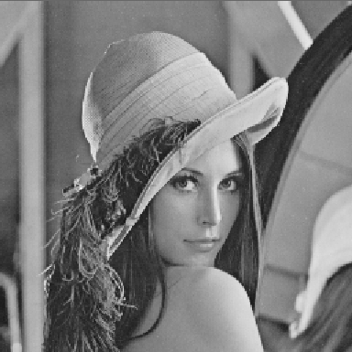

* Prewitt

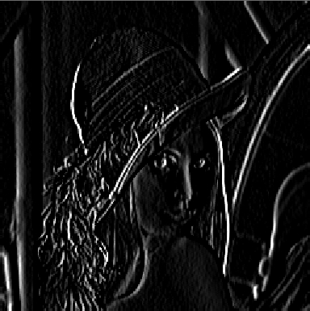

* Sobel

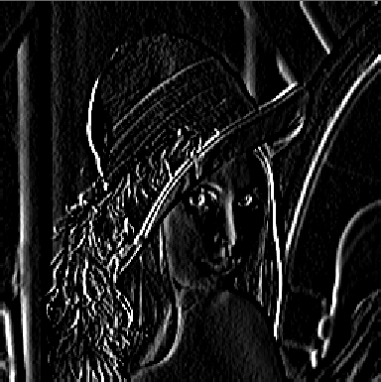

* Zoneplate

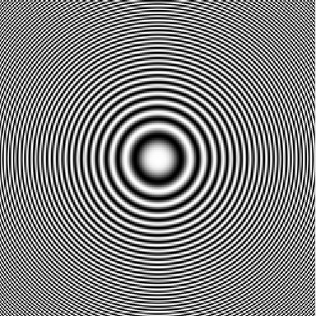

* Prewitt (W, NW, N)

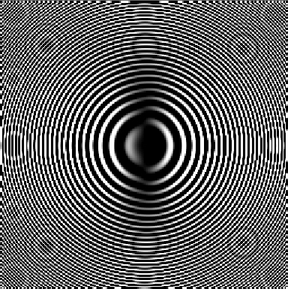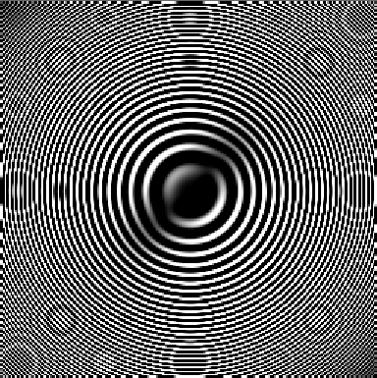

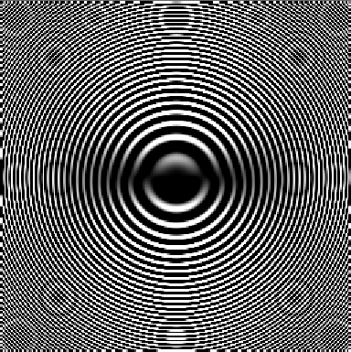

* Kirsh (NE, E, SE)

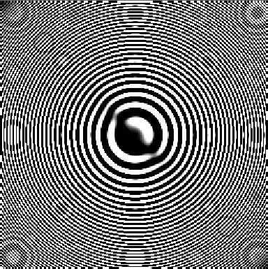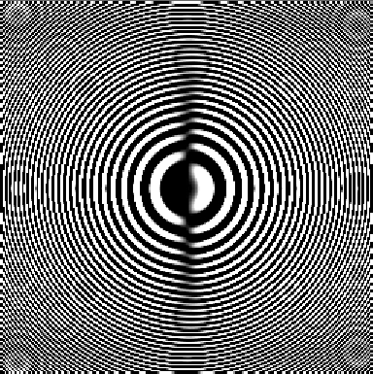

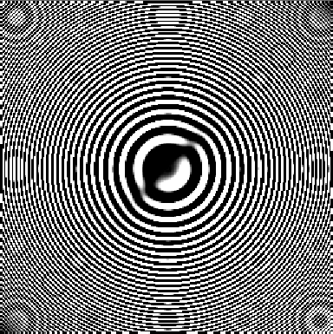

* Robinson 3 (S, SW, W)

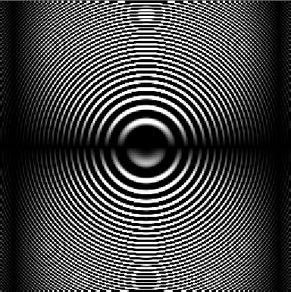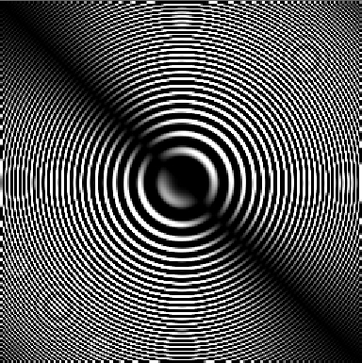

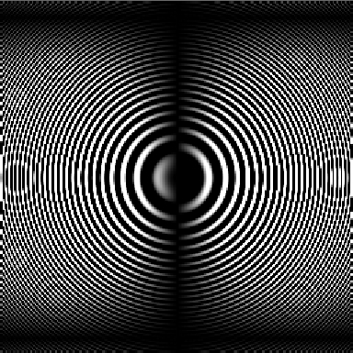

* Robinson 5 (S, SW, W)

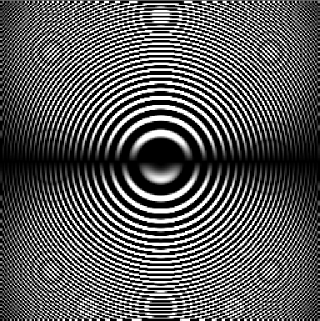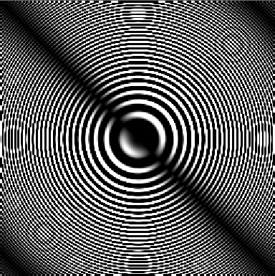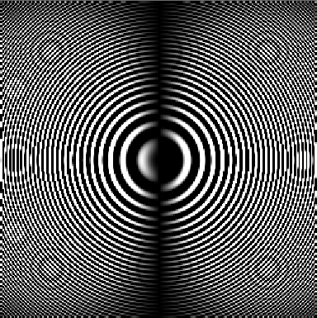

**< 실습 B >**

* Lena

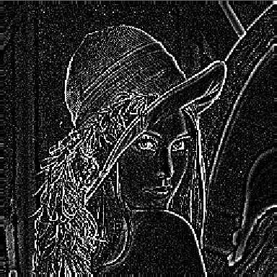

* Zoneplate

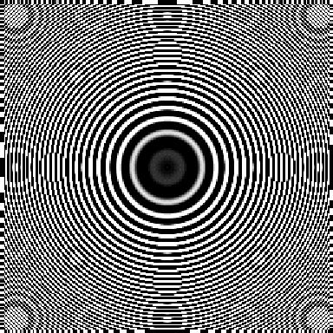

**< 실습 C >**

* Lena_g1, Lena_g2

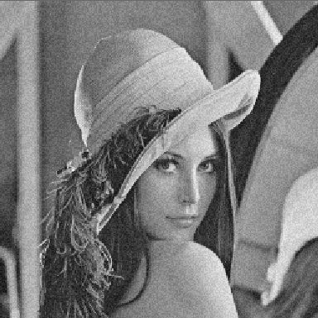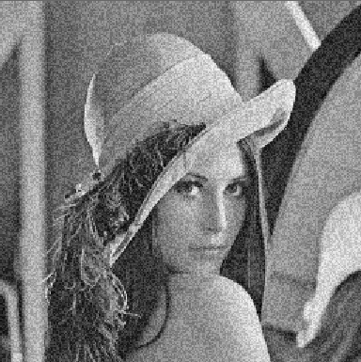

* Mean

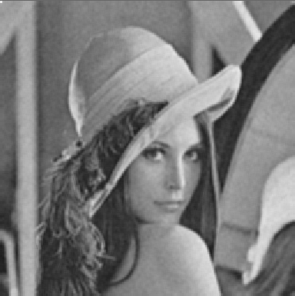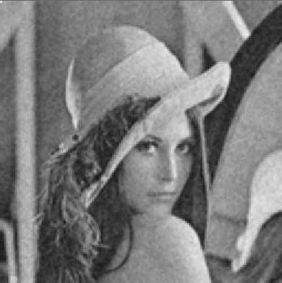

* Median

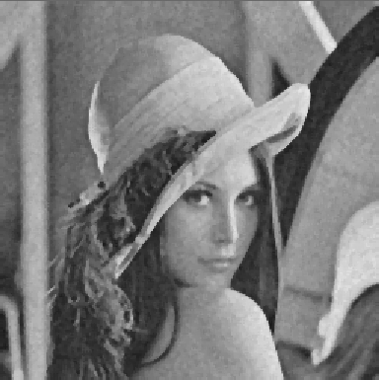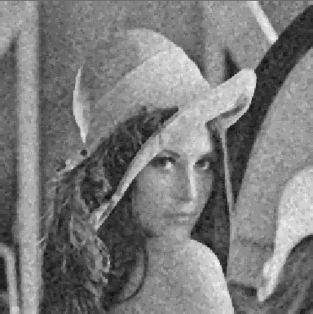

* Lena_s1, Lena_s2

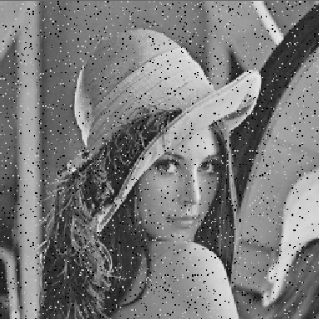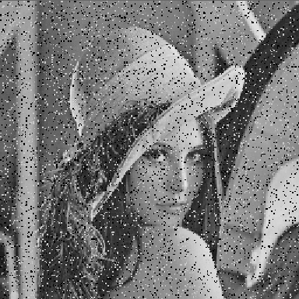

* Mean

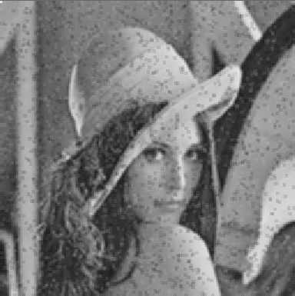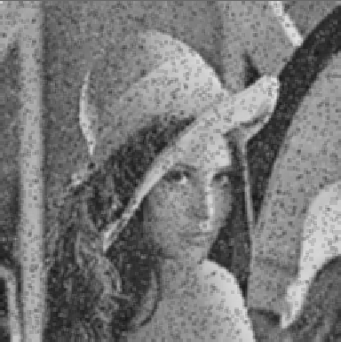

* Median

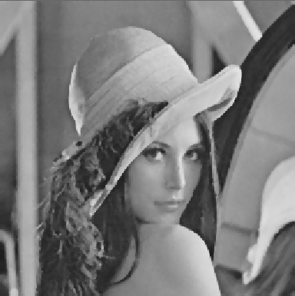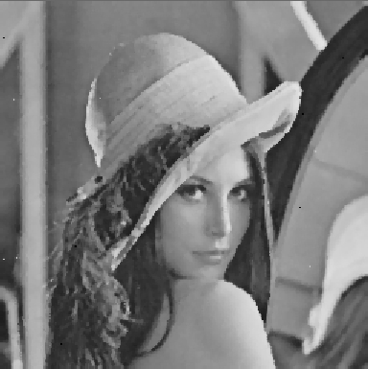

**< 코드 내용 >**

* LIST3_1.c

/* Prewitt */

float maskGx_Prewitt[3][3] = { {-1, -1, -1}, {0, 0, 0}, {1, 1, 1} };

float maskGy_Prewitt[3][3] = { {-1, 0, 1}, {-1, 0, 1}, {-1, 0, 1} };

/* Sobel */

float maskGx_Sobel[3][3] = { {-1, -2, -1}, {0, 0, 0}, {1, 2, 1} };

float maskGy_Sobel[3][3] = { {-1, 0, 1}, {-2, 0, 2}, {-1, 0, 1} };

/* Compass Prewitt */

float mask_compassPrewitt_W[3][3] = { {-1, 1, 1}, {-1, -2, 1}, {-1, 1, 1} };

float mask_compassPrewitt_NW[3][3] = { {-1, -1, 1}, {-1, -2, 1}, {1, 1, 1} };

float mask_compassPrewitt_N[3][3] = { {-1, -1, -1}, {1, -2, 1}, {1, 1, 1} };

/* Compass Kirsh */

float mask_compassKirsh_NE[3][3] = { {-3, -3, -3}, {5, 0, -3}, {5, 5, -3} };

float mask_compassKirsh_E[3][3] = { {5, -3, -3}, {5, 0, -3}, {5, -3, -3} };

float mask_compassKirsh_SE[3][3] = { {5, 5, -3}, {5, 0, -3}, {-3, -3, -3} };

/* Compass Robinson 3 */

float mask_compassRobinson3_S[3][3] = { {1, 1, 1}, {0, 0, 0}, {-1, -1, -1} };

float mask_compassRobinson3_SW[3][3] = { {0, 1, 1}, {-1, 0, 1}, {-1, -1, 0} };

float mask_compassRobinson3_W[3][3] = { {-1, 0, 1}, {-1, 0, 1}, {-1, 0, 1} };

/* Compass Robinson 5 */

float mask_compassRobinson5_S[3][3] = { {1, 2, 1}, {0, 0, 0}, {-1, -2, -1} };

float mask_compassRobinson5_SW[3][3] = { {0, 1, 2}, {-1, 0, 1}, {-2, -1, 0} };

float mask_compassRobinson5_W[3][3] = { {-1, 0, 1}, {-2, 0, 2}, {-1, 0, 1} };

/* LoG */

float mask_LoG[5][5] = { {0, 0, -1, 0, 0}, {0, -1, -2, -1, 0}, {-1, -2, 16, -2, -1}, {0, -1, -2, -1, 0}, {0, 0, -1, 0, 0} };

/* detect edge Gx using Prewitt */

// convolve(buffer, cols, rows, 3, 3, maskGx_Prewitt, 0, fileout);

/* detect edge Gy using Prewitt */

// convolve(buffer, cols, rows, 3, 3, maskGy_Prewitt, 0, fileout);

/* detect edge Gx using Sobel */

// convolve(buffer, cols, rows, 3, 3, maskGx_Sobel, 0, fileout);

/* detect edge Gy using Sobel */

// convolve(buffer, cols, rows, 3, 3, maskGy_Sobel, 0, fileout);

/* detect edge West using Prewitt */

// convolve(buffer, cols, rows, 3, 3, mask_compassPrewitt_W, 0, fileout);

/* detect edge NorthWest using Prewitt */

// convolve(buffer, cols, rows, 3, 3, mask_compassPrewitt_NW, 0, fileout);

/* detect edge North using Prewitt */

// convolve(buffer, cols, rows, 3, 3, mask_compassPrewitt_N, 0, fileout);

/* detect edge NorthEast using Kirsh */

// convolve(buffer, cols, rows, 3, 3, mask_compassKirsh_NE, 0, fileout);

/* detect edge East using Kirsh */

// convolve(buffer, cols, rows, 3, 3, mask_compassKirsh_E, 0, fileout);

/* detect edge SouthEast using Kirsh */

// convolve(buffer, cols, rows, 3, 3, mask_compassKirsh_SE, 0, fileout);

/* detect edge South using Robinson 3 */

// convolve(buffer, cols, rows, 3, 3, mask_compassRobinson3_S, 0, fileout);

/* detect edge SouthWest using Robinson 3 */

// convolve(buffer, cols, rows, 3, 3, mask_compassRobinson3_SW, 0, fileout);

/* detect edge West using Robinson 3 */

// convolve(buffer, cols, rows, 3, 3, mask_compassRobinson3_W, 0, fileout);

/* detect edge South using Robinson 5 */

// convolve(buffer, cols, rows, 3, 3, mask_compassRobinson5_S, 0, fileout);

/* detect edge SouthWest using Robinson 5 */

// convolve(buffer, cols, rows, 3, 3, mask_compassRobinson5_SW, 0, fileout);

/* detect edge West using Robinson 5 */

// convolve(buffer, cols, rows, 3, 3, mask_compassRobinson5_W, 0, fileout);

/* detect edge using LoG */

// convolve(buffer, cols, rows, 5, 5, mask_LoG, 0, fileout);

/* median and mean filter */

// median_filt(buffer, cols, rows, fileout, 3);

* median_filt.c

float mean(int* window, int wsize)

{

int i, sum = 0;

float mean;

quicksort(window, 0, wsize);

for (i = 0; i < wsize; i++)

sum += window[i];

mean = (float)sum / wsize;

return mean;

}

// new_pixel = mean(window, wsize);